CO1 | Examine the basic concepts of data mining and machine learning concepts
Task 1 | - Implement the Find-S algorithm to learn the most specific hypothesis from a dataset.  - Implement the Candidate Elimination algorithm to compute the version space for a concept.  - Compare the outputs of Find-S and Candidate Elimination on the same dataset.  - Understand how these algorithms behave with noisy or incomplete data.  Platform: Orange, Google co-lab, Anaconda navigator, Language: Python

FIND-S Algorithm:

Objective:
Given a dataset of weather conditions with binary attributes (Sunny/Rainy, Warm/Cold, Normal/High, Strong/Weak, Warm/Cool, Same/Change), the objective is to find the most specific hypothesis based on positive examples.

Algorithm:

Step 1: Start by iterating through the target values (tar).
If the target is "yes" (positive instance), copy the corresponding concept values into specific_h as the initial hypothesis. This hypothesis will be modified in the subsequent steps.
Step 2: Iterate through the concepts (con):
If the target for a given concept is "yes", compare each feature of the concept with the corresponding feature in specific_h.
If a feature in the concept does not match the corresponding feature in specific_h, replace that feature in specific_h with "?" (generalize the hypothesis).
Step 3: Continue this process until all positive instances are covered.
Step 4: Return the final specific_h, which will be the most specific hypothesis consistent with all positive examples.

Training Examples:
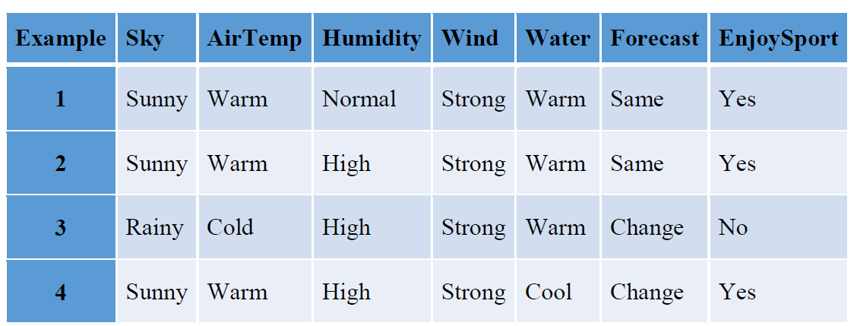

Program:
import pandas as pd
import numpy as np
data = pd.read_csv('/content/data1.csv')
concepts = np.array(data)[:,:-1]

concepts
target = np.array(data)[:,-1]

target
def train(con, tar):
for i, val in enumerate(tar):
if val == 'yes':
specific_h = con[i].copy()
break

for i, val in enumerate(con):
if tar[i] == 'yes':
for x in range(len(specific_h)):
if val[x] != specific_h[x]:
specific_h[x] = '?'
else:
pass
return specific_h
print(train(concepts, target))

Candidate Elimination algorithm
.

Algorithm:
Step 1: Initialization:
Set specific_h to the first positive example (the most specific hypothesis).
Initialize general_h as a list of general hypotheses, each filled with "?".
Step 2: Processing the instances:
For each example in the training set:
If the target is "yes" (positive instance):
For each feature in the concept, if it differs from the corresponding feature in specific_h, generalize the specific_h by replacing that feature with "?".
Also, the corresponding entry in general_h is consistent with the generalization.
If the target is "no" (negative instance):
For each feature, if the feature in the concept differs from specific_h, update the general_h to rule out this negative instance by specifying the feature value. If a feature matches, keep it as "?".
Step 3: Pruning general hypotheses:
Remove overly general hypotheses from general_h that are entirely made up of "?".
Step 4: Return the final specific_h (most specific hypothesis) and general_h (set of general hypotheses).

Program:

import numpy as np
import pandas as pd

data = pd.read_csv('/content/data1.csv')
concepts = np.array(data.iloc[:,0:-1])
target = np.array(data.iloc[:,-1])
def learn(concepts, target):
specific_h = concepts[0].copy()
print("initialization of specific_h \n",specific_h)
general_h = ["?" for i in range(len(specific_h))] for i in range(len(specific_h))]
print("initialization of general_h \n", general_h)

for i, h in enumerate(concepts):
if target[i] == "yes":
print("If instance is Positive ")
for x in range(len(specific_h)):
if h[x]!= specific_h[x]:
specific_h[x] ='?'
general_h[x][x] ='?'

if target[i] == "no":
print("If instance is Negative ")
for x in range(len(specific_h)):
if h[x]!= specific_h[x]:
general_h[x][x] = specific_h[x]
else:
general_h[x][x] = '?'

print(" step {}".format(i+1))
print(specific_h)
print(general_h)
print("\n")
print("\n")

indices = [i for i, val in enumerate(general_h) if val == ['?', '?', '?', '?', '?', '?']]
for i in indices:
general_h.remove(['?', '?', '?', '?', '?', '?'])
return specific_h, general_h

s_final, g_final = learn(concepts, target)

print("Final Specific_h:", s_final, sep="\n")
print("Final General_h:", g_final, sep="\n")

